**FINAL ADJUSTMENTS DOCUMENTATION ON OGIDI WEBSITE**

| **ISSUE TO SOLVE** | **EXPLANATION** |
| --- | --- |
| Replace this information with this here;  👇👇👇👇  IGWE-IN-COUNCIL |  |
| Create a new page for “Current and Past President-Generals of Ogidi” |  |
| Please create a page beside that of the current Igwe for this “ Past Royal Majesties of Ogidi” |  |
|  |  |

### 

### 

### 

### **Final Adjustment Approval Note**

This document outlines the final set of adjustments to be made on the website. By signing below, both parties agree that these are the last changes to be implemented as part of the current scope of work.

Any further modifications or additional features beyond this point will be treated as new requests and will attract additional costs, subject to a separate agreement.

**Signed:**

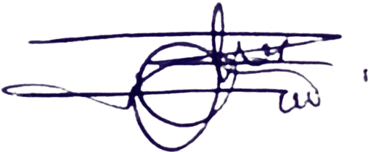

Website Developers of Ogidi Project  
Date: 14th June, 2025

**Approved by:**

[Client's Name/Company Representative]  
Date: ___________